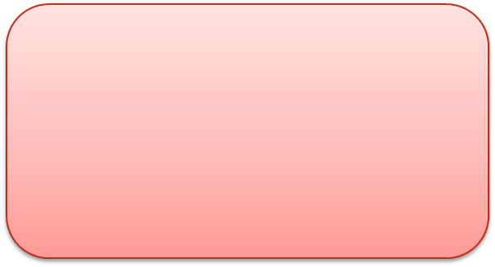***Historical Developments in Computer Science***

*From 1999-Present*

*From 1801-1970*

*From 1970-1999*